# Web Technologies and Development

Student Name: Nicholas Lane

Student Number: 221156236

Task: 5.1 Dkn Pizza

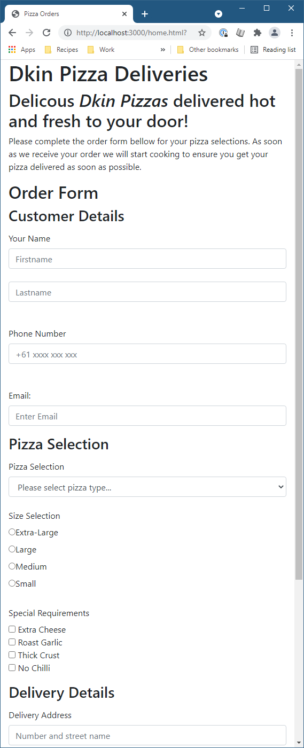

-- Document End --